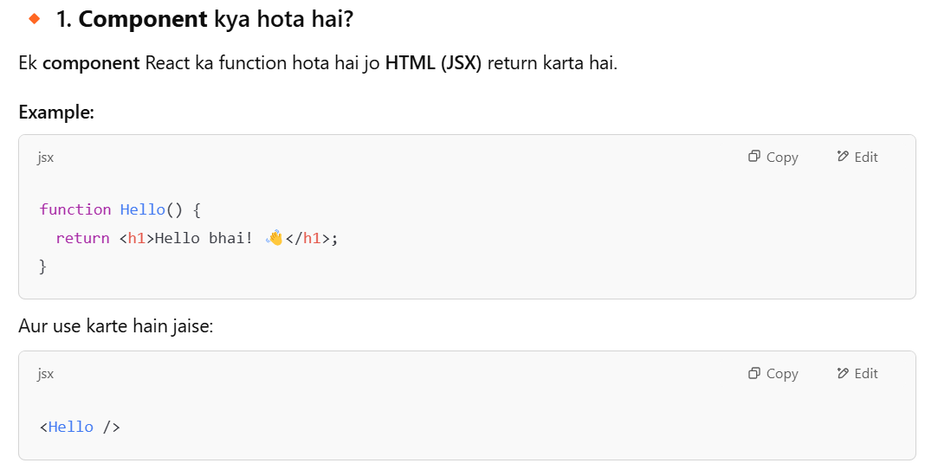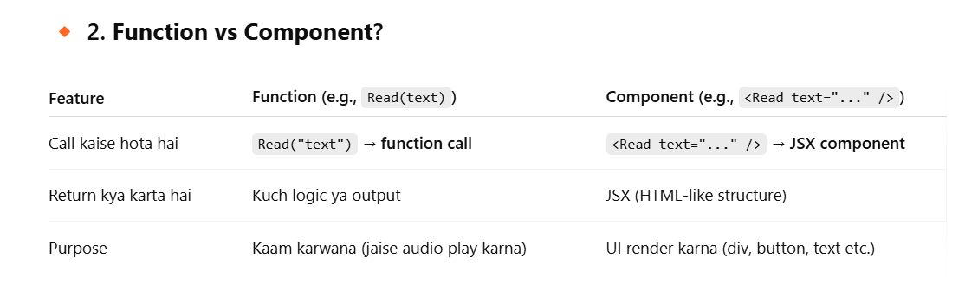

**🔥 Shortcut yaad rakh:**

* Read() → function hai, **kaam karega**
* <Read /> → component hai, **UI dikhayega**